H.T No
Regulations:
A20

Sreenidhi Institute of Science and Technology
(An Autonomous Institution)
Code No:8K201 Date:09 -August-2024 (FN)

B.Tech I-Year II- Semester External Examination, August-2024 (Supplementary)
ENGINEERING MECHANICS FOR CIVIL ENGINEERING (CIVIL)

Time: 3 Hours Max.Marks:70

Note: a) No additional answer sheets will be provided.
b) All sub-parts of a question must be answered at one place only, otherwise it will not be valued.
c) Missing data can be assumed suitably.

Bloom's Cognitive Levels of Learning (BCLL)

Remember | L1 | Apply | L3 | Evaluate | L5
Understand | L2 | Analyze | L4 | Create | L6

Part - A Max.Marks:20
Answer all QUESTIONS

 |  | BCLL | CO(s) | Marks
1 | State and prove Varigon’s principle | L2 | CO1 | [2M]
2 | Distinguish between Cone pulley and Jockey pulley. | L1 | CO2 | [2M]
3 | Explain Product of inertia and mass moment of inertia. | L1 | CO3 | [2M]
4 | Discuss in detail about stability of equilibrium of rigid bodies. | L2 | CO4 | [2M]
5 | Explain the difference between direct impact and oblique impact. | L1 | CO5 | [2M]
6 | Derive the expression for kinetic energy of a body rotating about a fixed axis. | L3 | CO6 | [2M]
7 | What is a couple? State it’s characteristics. | L1 | CO1 | [2M]
8 | Determine the centre of gravity of a solid hemisphere of radius r from its diametrical axis. | L3 | CO3 | [2M]
9 | Briefly explain the term impulsive force in kinetics of a particle. | L2 | CO5 | [2M]
10 | What are the assumptions made in finding the forces in members of truss? | L2 | CO6 | [2M]
Part – B Max.Marks:50
ANSWER ANY FIVE QUESTIONS. EACH QUESTION CARRIES 10 MARKS.

 |  |  | BCLL | CO(s) | Marks
11. |  | A uniform wheel 40 cm in diameter rests against a rigid rectangular block 10 cm thick as shown in  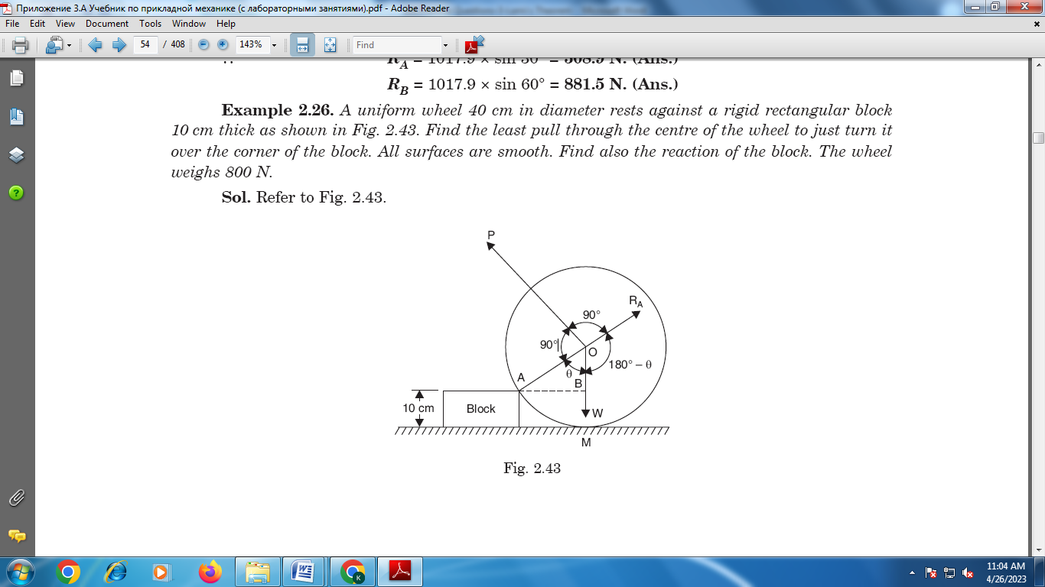  Fig. Find the least pull through the centre of the wheel to just turn it over the corner of the block. All surfaces are smooth. Find also the reaction of the block. The wheel weighs 800 N. | L5 | CO1 | [10M]
12. |  | Determine the force P required to start the wedge shown in Fig. The angle of friction for all surfaces in contact is 15°.  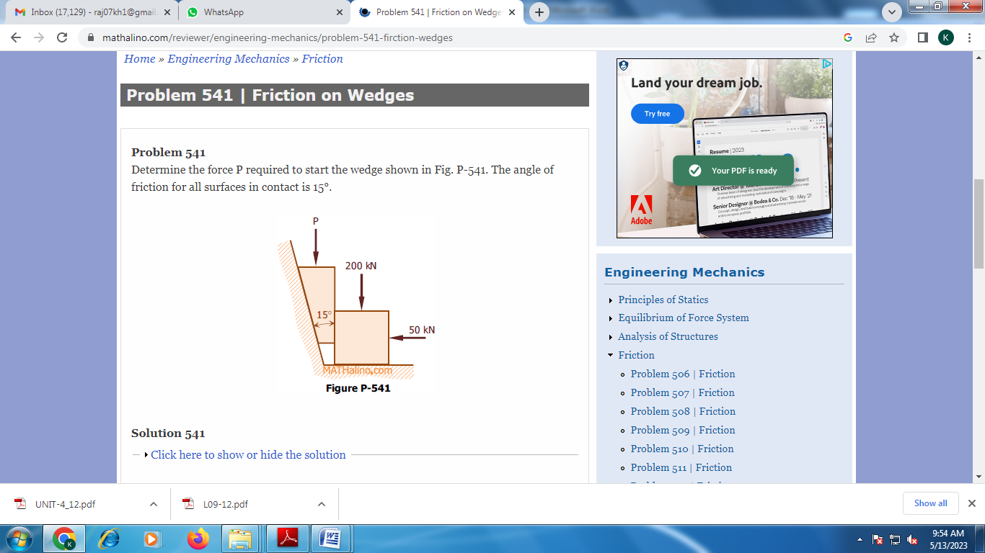 | L4 | CO2 | [10M]
13. |  | A T-section is 20×20×4mm as shown in Figure. Calculate the moment of inertia of the section about the x-x axis parallel to the base of T-section passing through its centroid.  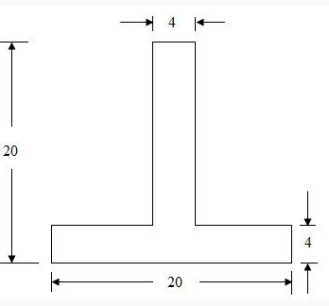 | L6 | CO3 | [10M]
14. |  | Using the principle virtual work, determine the vertical displacement at A of beam as shown in te figure.  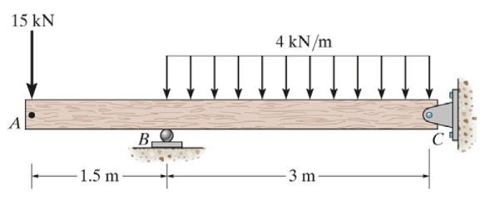 | L5 | CO4 | [5M]
15. |  | A bullet of mass 25 kg is fired with a velocity of 500 m/s into a wooden block resting against a rigid vertical wall. If the bullet is brought to rest in 0.5 ms, determine the average impulsive force exerted by the bullet on the block. Also calculate the impulsive force exerted if the mass of bullet is increased to 30g. | L5 | CO5 | [10M]
16. |  | A lift has an upward acceleration of 1.225m/s²,  a. What pressure will a man weighing 500N exert on the floor of the lift?  b. What pressure would he exert if the lift had an acceleration of 1.225 m/s² downwards?  c. What upward acceleration would cause his weight to exert a pressure of 600 N on the floor? | L6 | CO6 | [10M]
17. | a) | Discuss Free body diagrams used in equilibrium. | L2 | CO1 | [4M]
 | b) | Explain different methods of finding forces in the frame. | L3 | CO2 | [3M]
 | c) | State and prove Parallel axis theorem. | L2 | CO3 | [3M]
18. | a) | State and explain Principle of virtual work. | L2 | CO4 | [4M]
 | b) | What is the difference between central impact and oblique impact? | L1 | CO5 | [3M]
 | c) | Derive the work energy equations for translation. | L3 | CO6 | [3M]
-- 00 -- 00 –

